INTERNAL Requirements Specification – Title Goes Here

Date: | 02-Jun-2025 | Tracker:
BA: | Sankar Ram S | Release Number: | 2025.2
Developer: | Nived PK / Ankit Chourey | Sprint Number: | 1 to 4
Peer Reviewer: | Jim Kiley / Rubini Omkumar | Customer: | All

Revision History
Date | Version ID | Author | Change
02-Jun-25 | 1 | Sankar Ram S | Initial Draft

***INTERNAL DESIGN SPECIFICATION***

1. Design Requirements
Business Reason

This document defines the Phase 1 integration of Epicor Eclipse 2025.2 with Epicor ECM (DocStar) for content storage and basic content‑management capabilities. The objective is to replace Eclipse’s on‑prem file shares with DocStar—either cloud‑hosted or on‑prem—while preserving the existing user experience within the Eclipse Imaging window.

Phase 1 delivers four core use‑cases:
• Automatic syncing of attachments linked to Eclipse Record IDs into DocStar.
• Display of those documents inside the Eclipse Imaging window.
• Secure download (“Save As”) by end‑users.
• Hard deletion of documents from DocStar via Eclipse, preceded by an in‑app confirmation message.

Functionality such as advanced workflows, forms, reporting, e‑signatures, and package management is explicitly deferred to later phases.

1.1 Current‑State Overview

Attachment Lifecycle in Eclipse
Users manually drag‑and‑drop files into the Eclipse Imaging window or external systems post files to Eclipse via the REST layer. Documents are stored on an on‑prem network share and indexed only by Record ID and Content Type. Eclipse does not track creation or update events for these attachments.

Imaging Window UX
Within any transaction or master‑record screen, a Gallery icon in the toolbar launches the Imaging window. Also there is a menu User tools Imaging. The window lists all existing attachments for that Record ID and offers View, Save As, and Edit options.

1.2 Future‑State Architecture
Figure 1 – Eclipse ↔ DocStar Phase 1 High‑Level Architecture

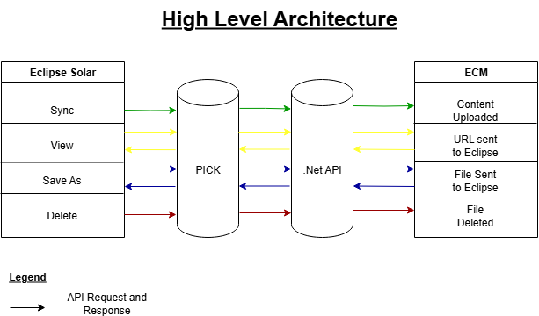

Data‑Flow by Use‑Case:

• Sync – Integration Service pulls newly linked files from Eclipse on demand and POSTs them to DocStar.
• View – Imaging window issues a GET search to DocStar for Record ID and renders the response.
• Save As – Imaging window streams file bytes from DocStar through the Integration Service.
• Delete – Imaging window sends DELETE request; DocStar hard‑deletes and returns 204 No Content.

1.3 API Specifications & Endpoint Catalog

Use‑Case | HTTP Verb | Endpoint | Auth | Success Response | Notes
Sync attachment | POST | Service at /AstriaV2/FileTransfer.svc/restssl/UploadFile  Service at /AstriaV2/ContentType.svc/restssl/GetContentType  Service at /AstriaV2/Security.svc/restssl/GetAllSecurityClasses  Service at /AstriaV2/Document.svc/restssl/Create | Basic (admin) | 201 Created + docId | Binary upload + metadata
View File | POST | /AstriaV2/Search.svc/restssl/Search - to get document id ( or store it in the DB during creation, may not be required)  /AstriaV2/Document.svc/restssl/PrepForSend  /AstriaV2/FileTransfer.svc/restssl/DownloadFile | Basic | 200 OK + array | Populates Imaging window
Save As file | POST | /AstriaV2/Document.svc/restssl/PrepForSend  /AstriaV2/FileTransfer.svc/restssl/DownloadFile | Basic | 200 OK (stream) | Triggered by “Save As”
Delete file | POST | Service at /AstriaV2/FileTransfer.svc/restssl/DeletePublicImage | Basic | 204 No Content | Hard delete with Eclipse warning
Connection | POST | Service at /HostingV2/User.svc/restssl/LogIn | None | 200 OK | Optional Ops monitor

Design Details

Describe the first part of the slice and include any flow charts showing routines and files.

1.1. Connection Settings Screen

As a user I should be able to maintain the settings related to ECM in Eclipse so that Eclipse can successfully connect with ECM

This screen will be available in API configurations screen.

1.1.1. Functionality

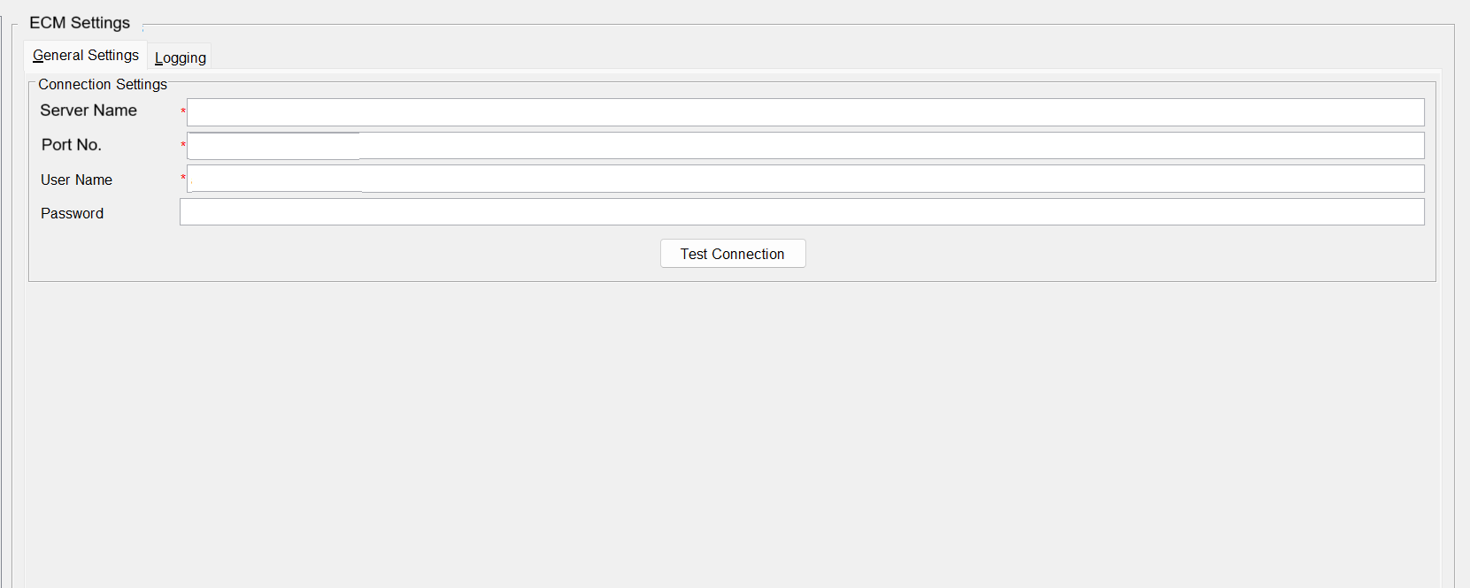

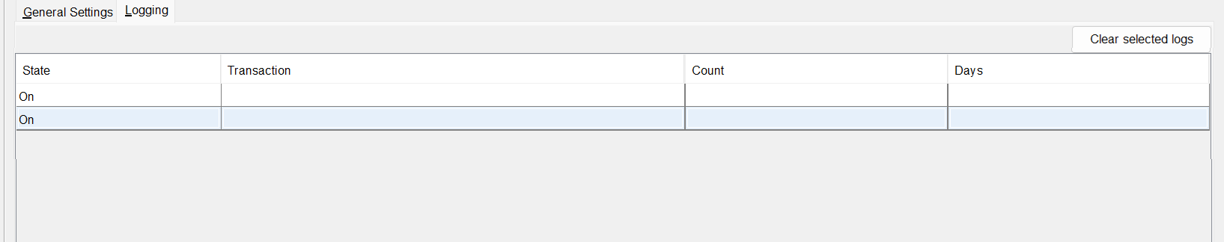

1.1.2. Design Considerations

User Should be able to enter and save the admin credentials which will be used for integration with ECM.
This screen should be accessed only by Eclipse Admin user.
There will be logs maintained to capture the changes in the screen.
The “Logging” tab will be used to set the purging of the logs.
Transaction Type – Connection, Sync, View, Download and Delete

1.2. Sync / upload of the content

As a user I should be able to sync the images I upload directly to Eclipse to ECM so that ECM becomes the single repository of all the Eclipse related images

1.2.1. Functionality

Both user uploaded images and images uploaded by external application like Eclipse mobile, POD, WMS etc needs to be synced to ECM

1.2.2. Design Considerations

Payload Schemas & Field Mapping
Key metadata transmitted with each document:
• Id (string, required)
• contentType
• keywords (string, optional)
• title (string; original filename)
• userId (string; Eclipse user who attached)

Following are the content type which is there in Eclipse today and will be used in Doctar
- User ID
- Entity
- Ledger
- Product
- Activity Log
- Product Cat
- MSDS Sheet
- MTR Sheet
- Manifest
- Service Visit

1.3. View of the Content

As a user I should be able to open an image in ECM from Eclipse for any master or transaction so that ECM becomes the image repository and Eclipse does not store any images

1.3.1. Functionality

When user right clicks and select “View Image” or choose File → View Image from User Tools → Imaging → View Images menu, the image should open in ECM. Login Authentication should happen automatically.

1.3.2. Design Considerations

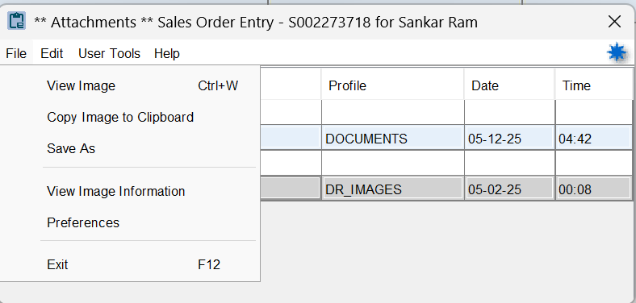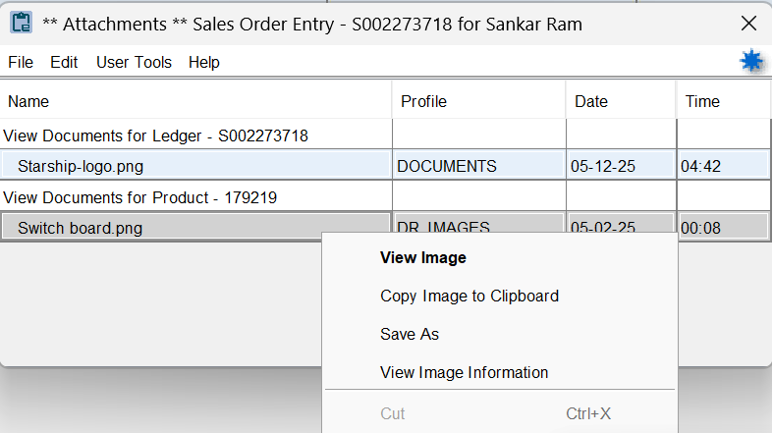

1.4. Download of the Content

As a user I should be able to download the image from ECM to my PC via Eclipse anytime so that I can have a downloaded copy of the file

1.4.1. Functionality

The action can be done from window menu or right click menu.

1.4.2. Design Considerations

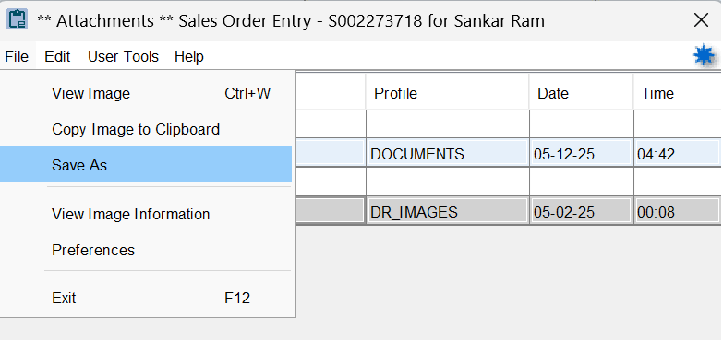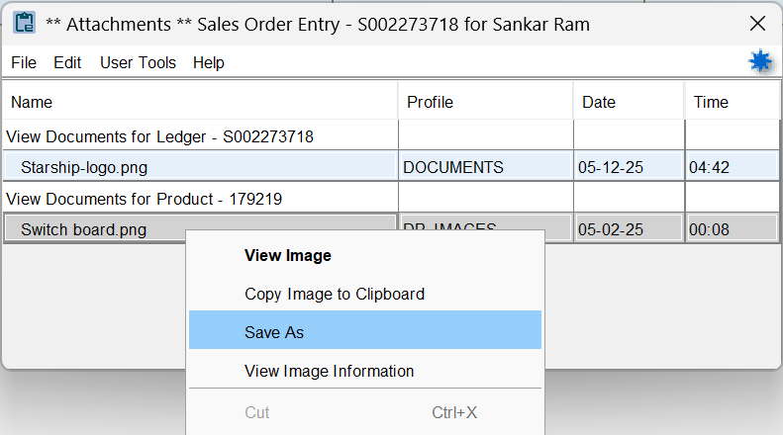

1.5. Delete of the Content

As a user I should be able to delete the image in ECM via Eclipse so that unwanted image can be deleted without logging into ECM

1.5.1. Functionality

Clicking on the Delete option in the Imaging menu should pop up a warning message stating that “The image will get permanently deleted in ECM. Do you want to Proceed?” with Yes / No buttons.

1.5.2. Design Considerations

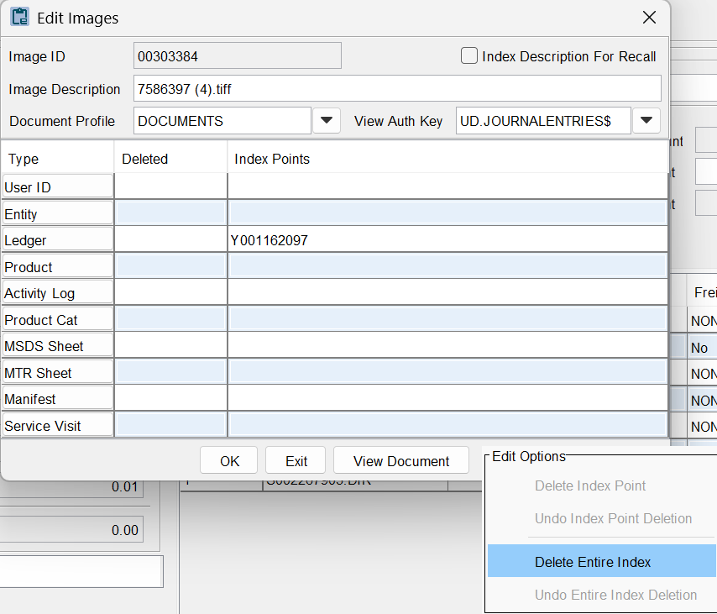

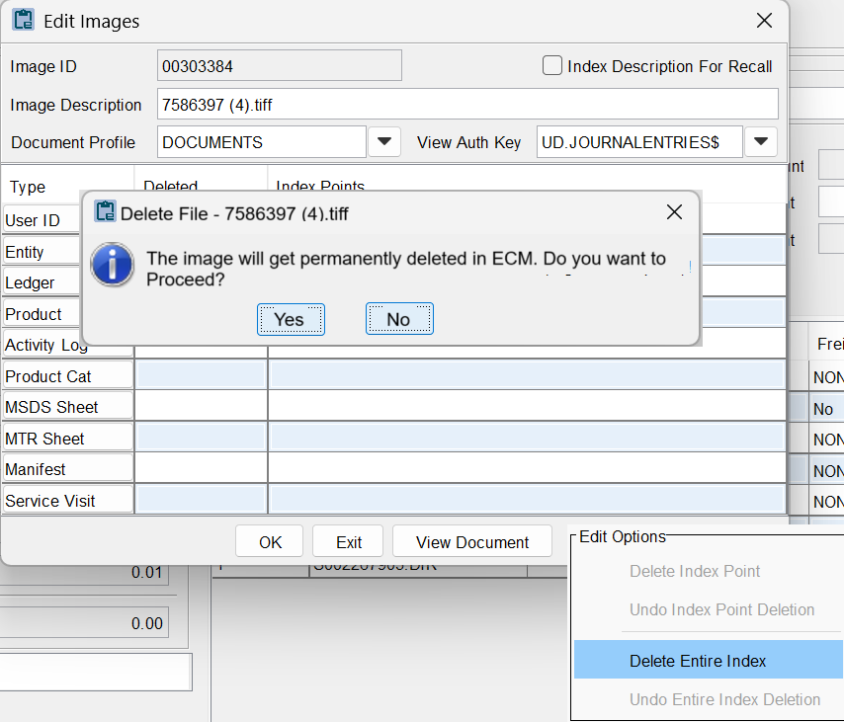

2. Q/A Concerns
NIL

3. Support or Release Concerns
NIL

4. Notes / Figures

Non‑Functional Requirements
• Performance – Imaging window list call < 2 s for up to 100 docs.
• Scalability – Support ≥ 50 concurrent viewers.
• File size – Up to 250 MB per attachment (DocStar limit).
• Availability – 99.5 % monthly uptime for DocStar SaaS.

Security & Compliance
• Docstar Admin Credentials stored in Eclipse API Configuration Screen.
• API Activity log: Connection, upload, download, delete events (user, timestamp, recordId, docId).

Migration Strategy
A one‑time historical back‑fill will be executed by Professional Services at implementation time. This project covers only new/changed files post cut‑over.

Features Not Included in Phase 1
Category | DocStar Capability
AR Workflow Automation | Graphical designer, dashboard, alerts
Intelligent Data Capture for other documents (except AP invoice) | OCR, barcode, smart extraction
Electronic Forms | Form Designer & public links
DocuSign Integration | e‑Signature envelopes
Exago Reporting | Standard & custom reports
PackageWorks | Structured document packages
Export Utility | Scheduled bulk export
Versioning & Check‑In/Out | Version history, locks

Risks, Assumptions & Constraints
• Performance metrics assume < 100 attachments per record.

5. Terms
NIL

